Customer NameDocument Title

INTERNAL
: Resorts World at Sentosa Pte. Ltd.

RWS
TECHNICAL SPECIFICATION – INTERFACE

R2R-Bank-I-001 TS Inbound interface for Incoming EBS (CAMT.053, MT940)

Contents
1 Document Organization 5
1.0 Document Log 5
1.1 Integration, Document Reference 5
2 Clean Core Compliance 6
3 Program Attributes 6
3.1 Selection Parameter / Filter 7
3.2 Validation 7
3.2.1 Selection Criteria validations 7
3.2.2 Interface parameter validations 7
3.2.3 Other validations 7
3.3 Authorization Requirements 8
3.4 Definition 8
3.5 Defined Fields 8
3.6 Procedure 8
3.7 Technical Flow Diagram 8
3.8 Processing Logic 8
3.8.1 Validation 8
3.8.2 Mapping 8
3.8.3 Error Handling 8
3.8.4 Custom DDIC Objects 8
3.8.5 Custom CDS View Entity Details 8
3.8.6 BRF+ Design 9
3.9 Reusable Code 9
3.10 File Attributes 9
3.11 Internal Tables 9
3.12 Messages 10
3.13 Selection Text 10
3.14 Text Elements 10
3.15 Subroutines 10
4 Interface List Output 11
4.1 Field Details 11
4.2 Layout 11
4.3 Interface List Header & Footer 11
5 Application logs/Monitoring 11
6 Assumptions in Technical Design 11
7 Open Issues in Technical Design 11
8 Unit Test Results 11
9 Related Documentation 11

Document Organization
This section provides details about this document, previous version(s) of this document and the document(s) referred.

Document Log
Following table mentions the version changes and the processer(s):
Version | Status | Date | Version Created by (Name/E-Mail/Company) | Role | Comments
1.0 | Draft | June 24, 2025 | Ridhima Aggarwal | Author | Initial Draft

Integration, Document Reference
N/A
S. No. | Referred Document Name | Referred Document Version | Referred Document URL (Optional)

Clean Core Compliance
N/A
Final Solution | Category | Comments
 | Choose an item.

Program Attributes
Program title | ZGW_FI_BANK_EBS
Program Name | ZGW_FI_BANK_EBS
Program Type | ODATA
Package | ZFI
Authorization Group
Type of Interface | Asynchronous
Mode of Execution | Online or Background

Transaction Code
Include Programs
Function Modules
Message Class

Classes
Generic Classes / Utility Classes
AMDP Classes
Proxy Class
FEH action class
Basic IDoc type
IDoc extension
Custom IDoc segment(s)
AIF Function module
API Name
CDS Name
Behavior Definition
Behavior Implementation Class
Service Definition
Service Binding

Selection Parameter / Filter
N/A
Single Valued / Range | Mandatory | Value Help | Default Value | User Text

Validation
N/A

Selection Criteria validations

Interface parameter validations

Other validations

Authorization Requirements
N/A

Definition
The purpose of this document is to consume EBS Files i.e. CAMT.053 and MT940 from Bank’s server into SAP and store it in AL11 Directory.

Defined Fields
N/A

Procedure
- Bank will send the statements to S4HANA via CPI.
- CPI will send the same payload to S4HANA by calling ODATA API ‘ZGW_FI_BANK_EBS’.
- ODATA will create the file in AL11 directory.

Technical Flow Diagram
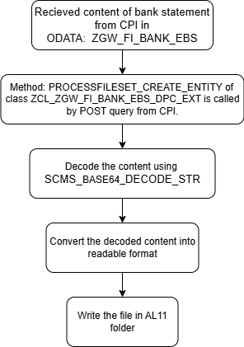

Processing Logic
- ODATA ZGW_FI_BANK_EBS will be called to store the bank file in AL11.
- Below is the Entity structure created for ODATA.
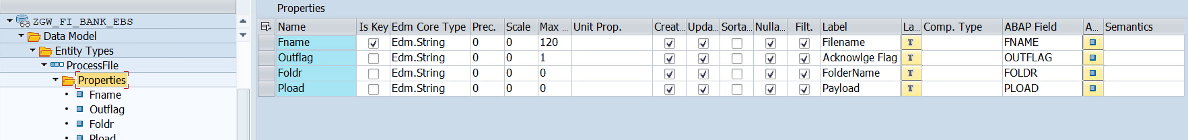
- Method ‘PROCESSFILESET_CREATE_ENTITY of class ZCL_ZGW_FI_BANK_EBS_DPC_EXT will be called by POST query from CPI to create the file in AL11 directory.
- Decode the Content of the file received from CPI in parameter ‘PLOAD’ of entity by using FM ‘SCMS_BASE64_DECODE_STR’.
- Convert the Decoded content of the file into string using FM ‘CACS_CONVERT_HEX_TO_STRING’ if file is of type TXT else convert it using method CONVERT_FROM of class CL_ABAP_CODEPAGE.
- Fetch the DIRNAME from table USER_DIR by passing ALIASS as DIR_INTERFACE.
- Create the filename as per folder received in payload from bank in parameter ‘FOLDR’ of entity.
- Write the file in AL11 using OPEN DATASET and CLOSE DATASET.

Validation
N/A

Mapping
N/A

Error Handling
N/A

Custom DDIC Objects
N/A

Custom CDS View Entity Details
N/A
Custom CDS entity Name
Primary View
Associated Views

BRF+ Design
N/A

Reusable Code
N/A

File Attributes
Same details mentioned in corresponding CPI Document.
File Type | Excel, ASCII, etc.?
Delimited / Fixed width | Comma, tab?
Header Record? | Provide layout
Footer Record? | Provide layout
Number of File Layouts and Description
File Layout(s) | Complete one per file layout (i.e., one for header records and one for detail records):

Messages
N/A
Message Class | Message ID | Message Text

Selection Text
N/A
Name | Description

Text Elements
N/A
Name | Text Description

Subroutines
N/A
Name | Description

Interface List Output

Field Details
N/A

Layout
N/A

Interface List Header & Footer
N/A

Application logs/Monitoring
N/A

Assumptions in Technical Design
N/A

Open Issues in Technical Design
N/A

Unit Test Results
Scenario # | Input Selection Criteria | Expected Result | Actual Test Pass/Fail
1 | Files Received from BANK | File stored in allocated folder for the bank | Pass

Related Documentation
N/A

Template Version

Version | Status | Date | Version Created by | Reviewer | Approver | Comments
1.0 | Final | February 11, 2019 | Abhishek Nayak | Jagmeet Singh | Modak Gupta | Initial version created
2.0 | Final | Oct 18, 2023 | Ravish Ranka | Jagmeet Singh | Modak Gupta | Updates according to latest development guideline

